- 8 Bit Addition

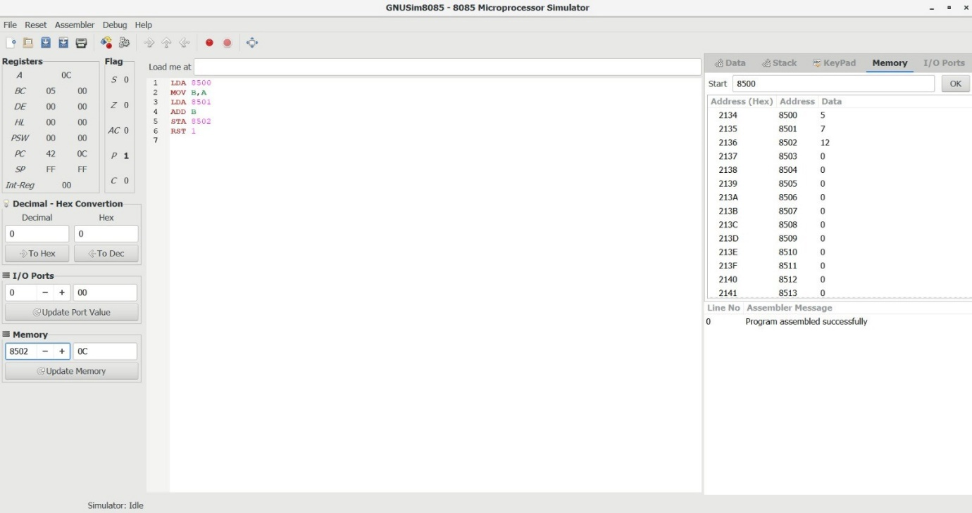

- 8 Bit Subtraction

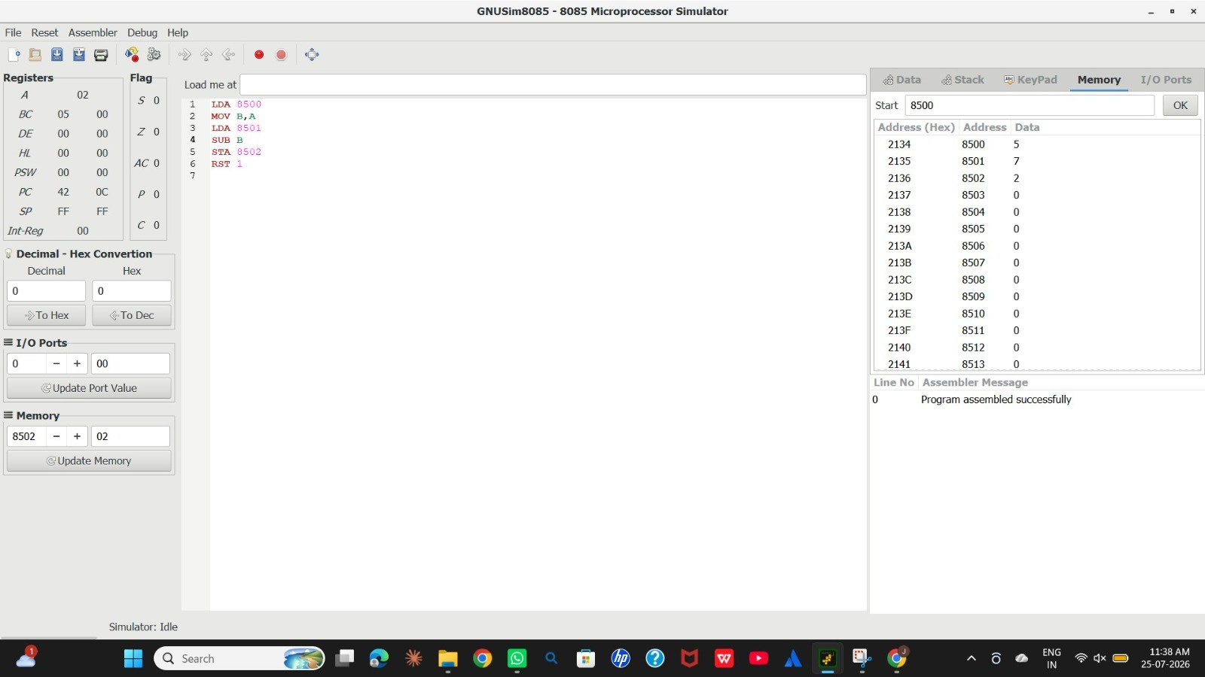

3) 8 Bit Add with carry
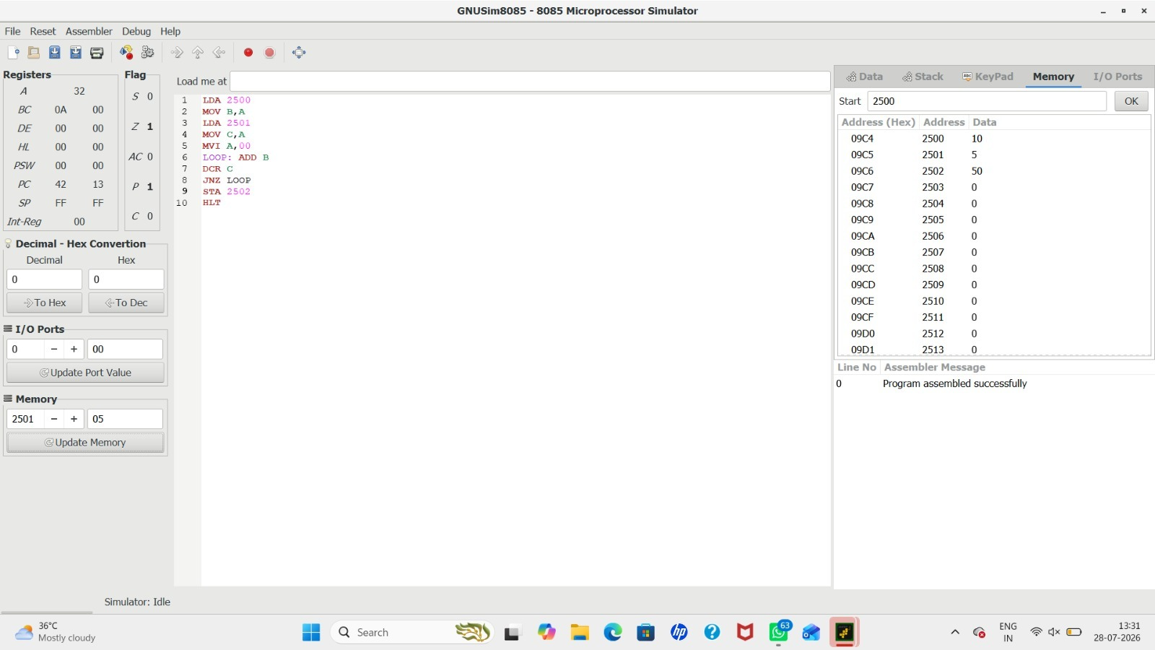

4) 8 Bit Sub with Borrow
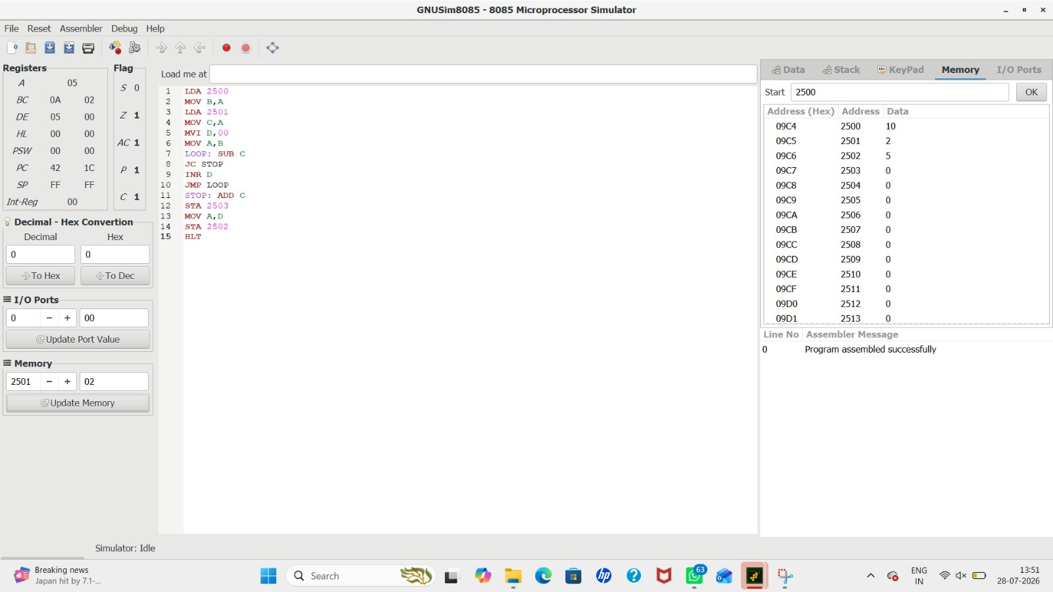

5) 8 Bit Multiplication


6) Division with Quotient
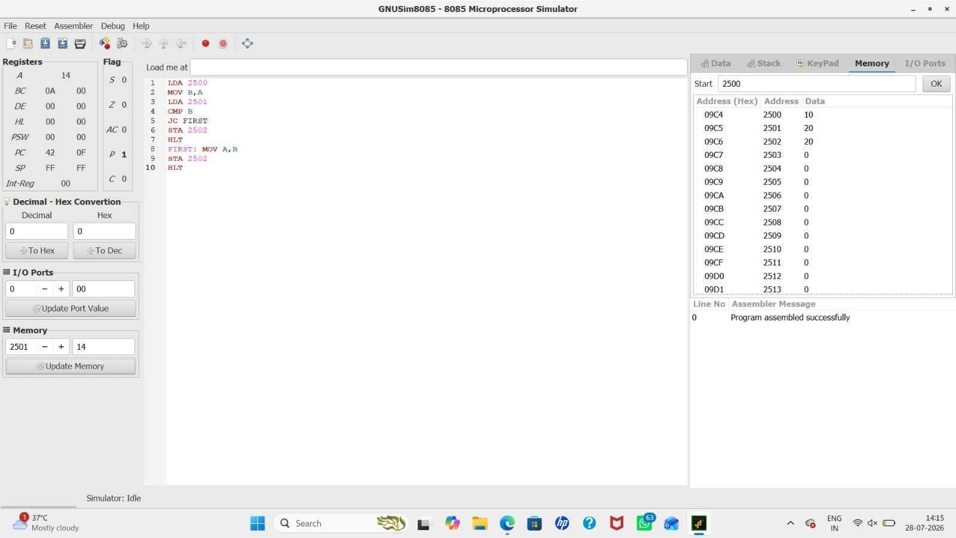

7) Division without Quotient


8) Greatest Of 2 Numbers
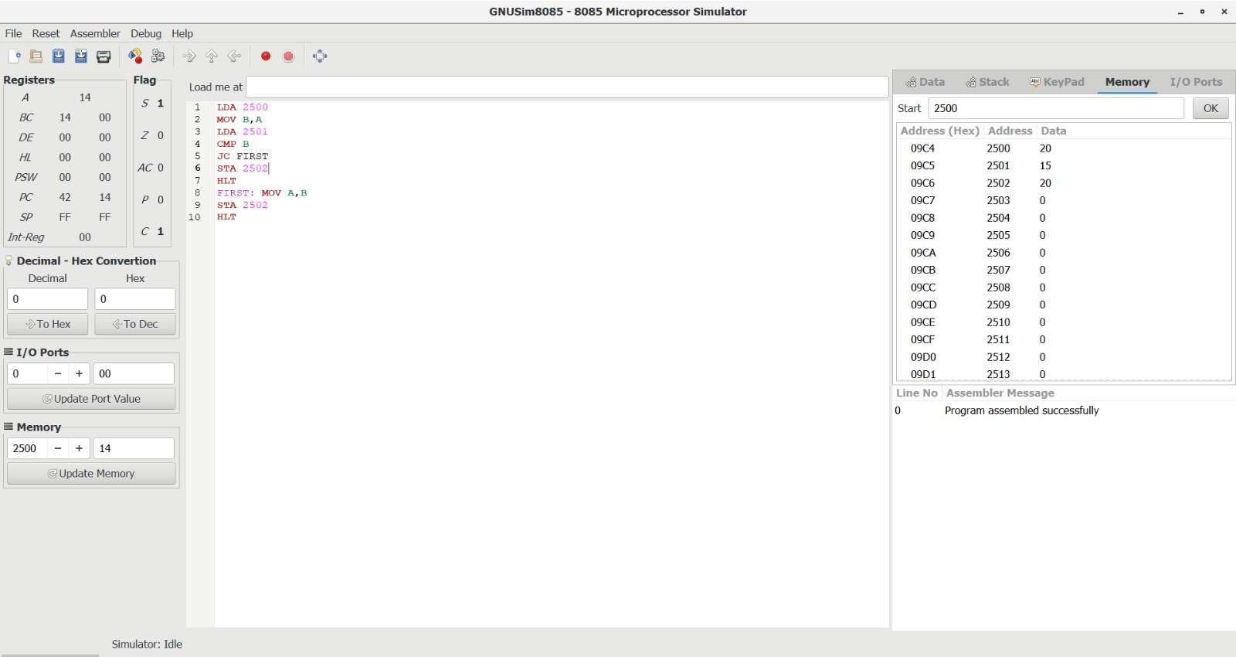

9) Smallest Of 2 Numbers
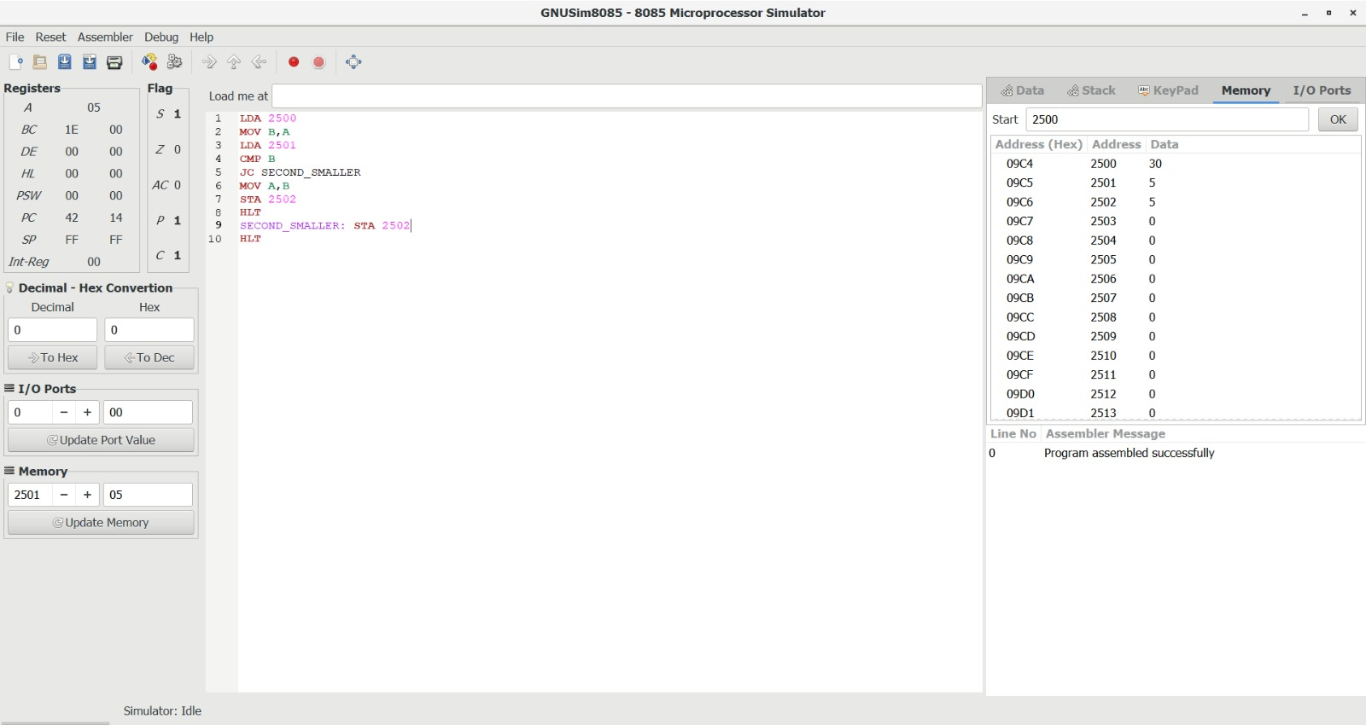

10) Swapping
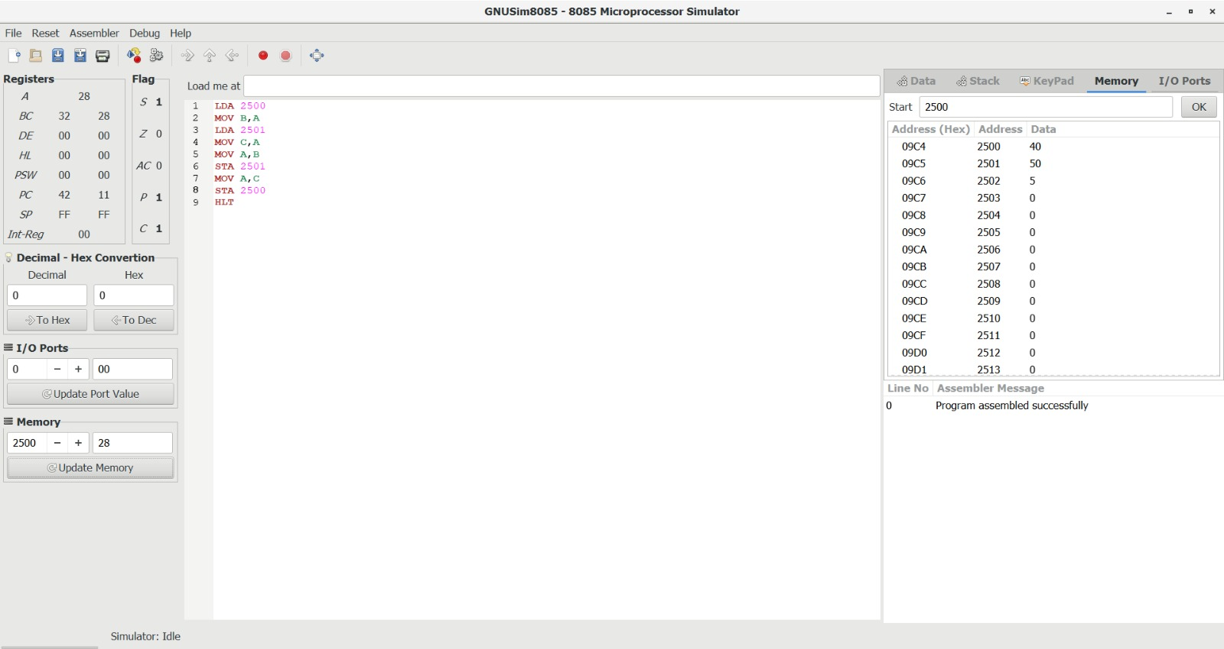

11) 1s Complement
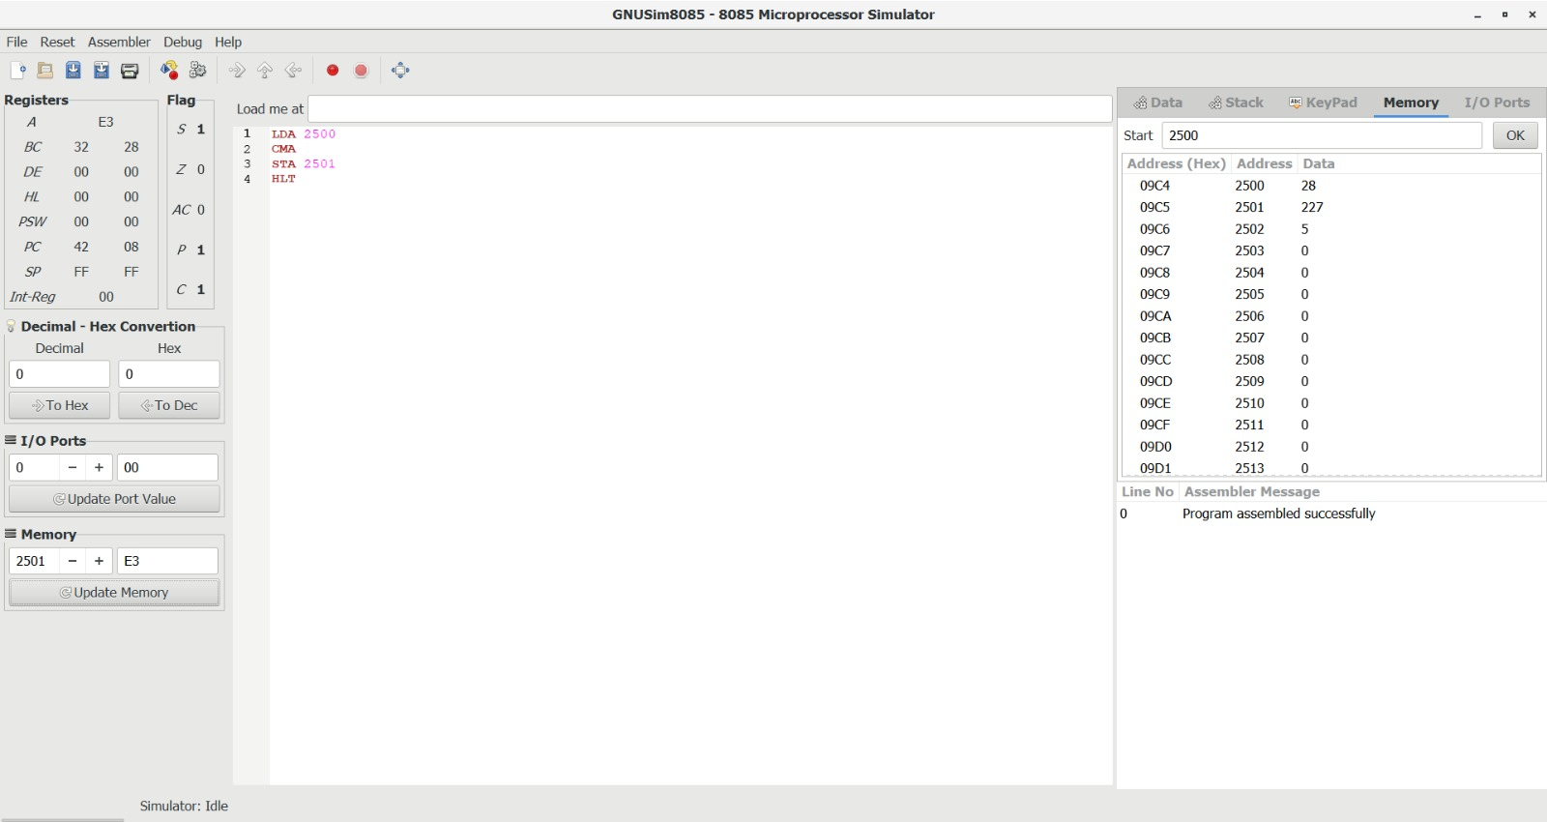

12) 2s Complement
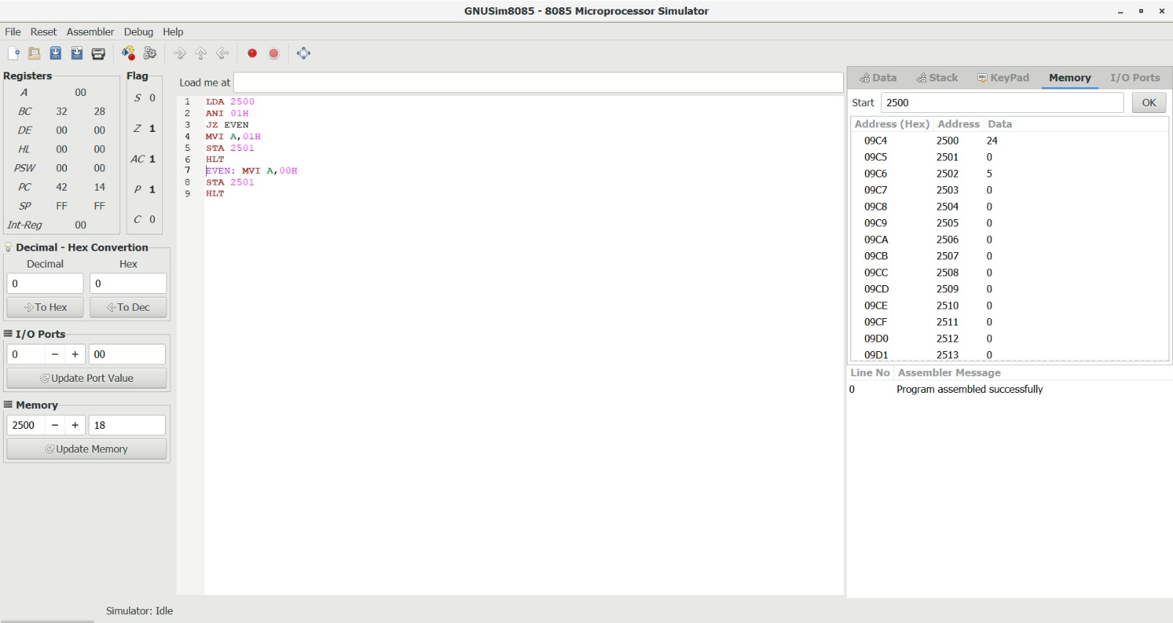

13) Odd/Even
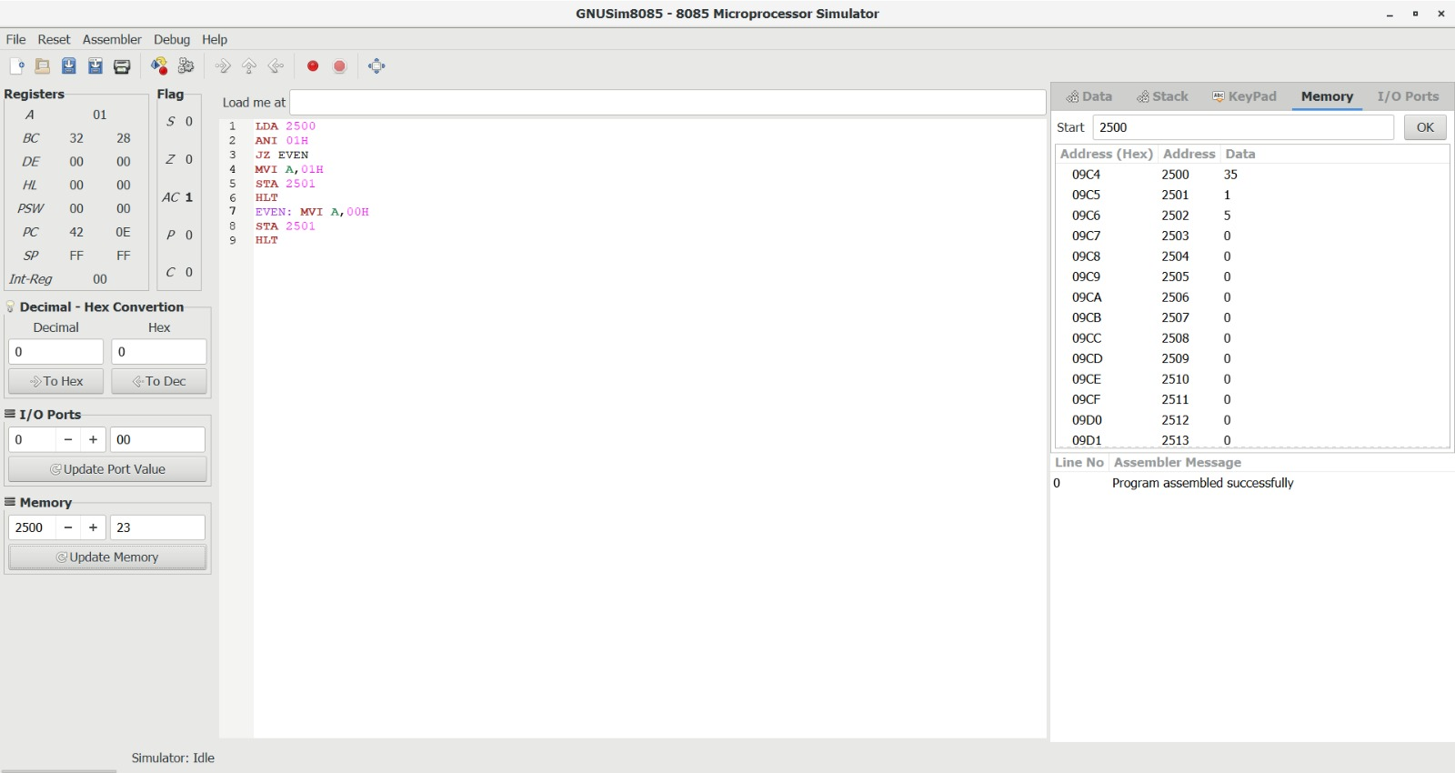

14) Positive/Negative
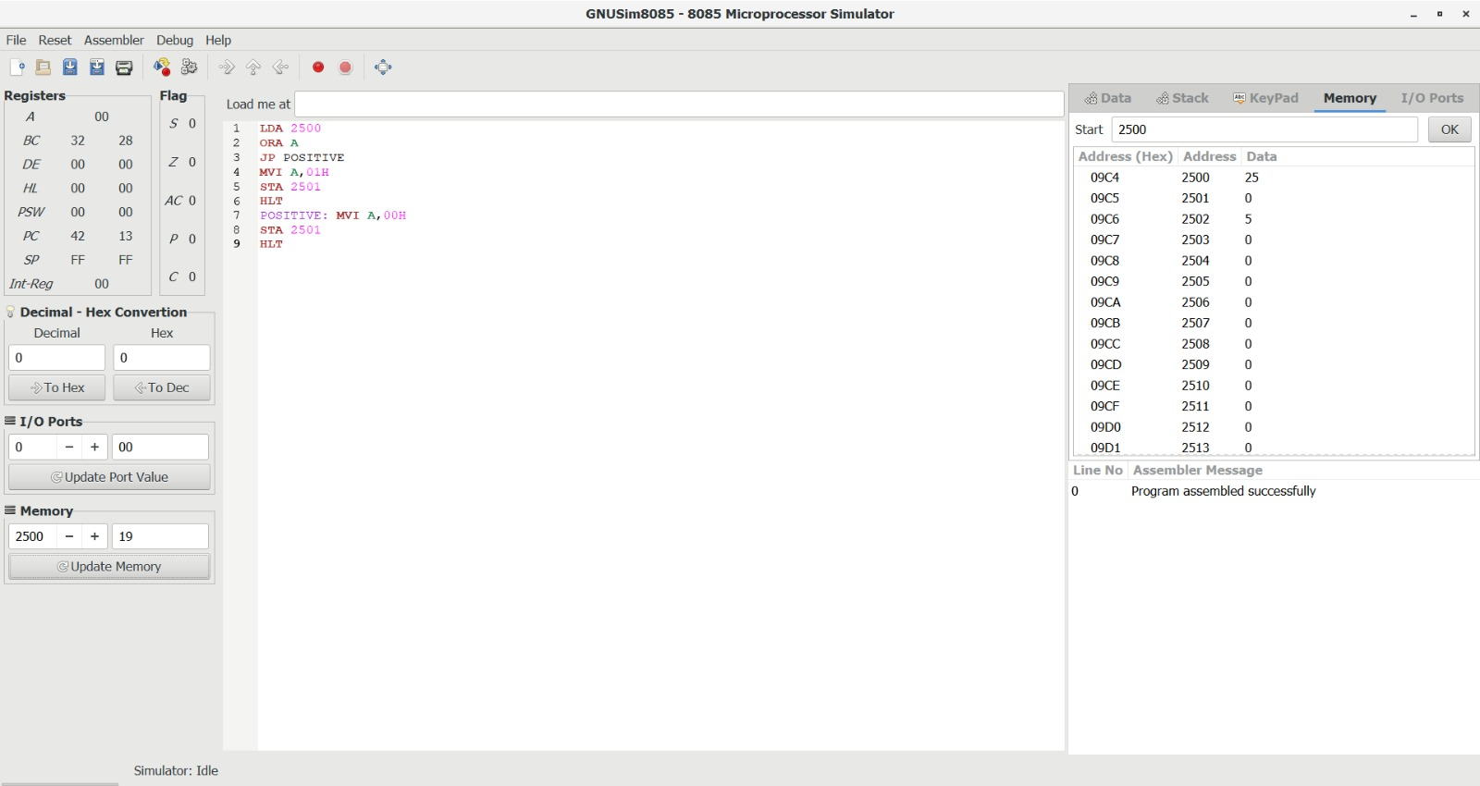

14. Write an assembly language program to arrange numbers in Ascending order.

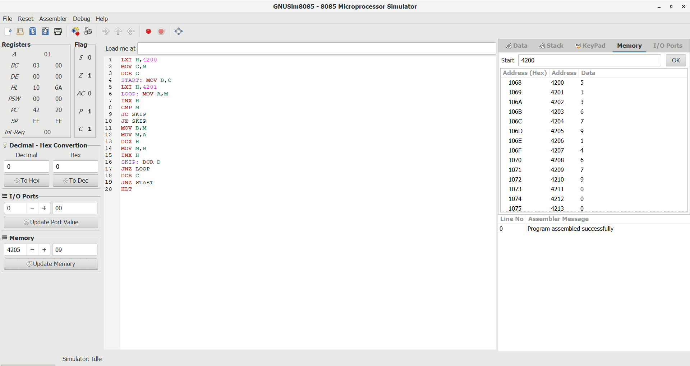

15.Write an assembly language program to arrange numbers in Descending order.

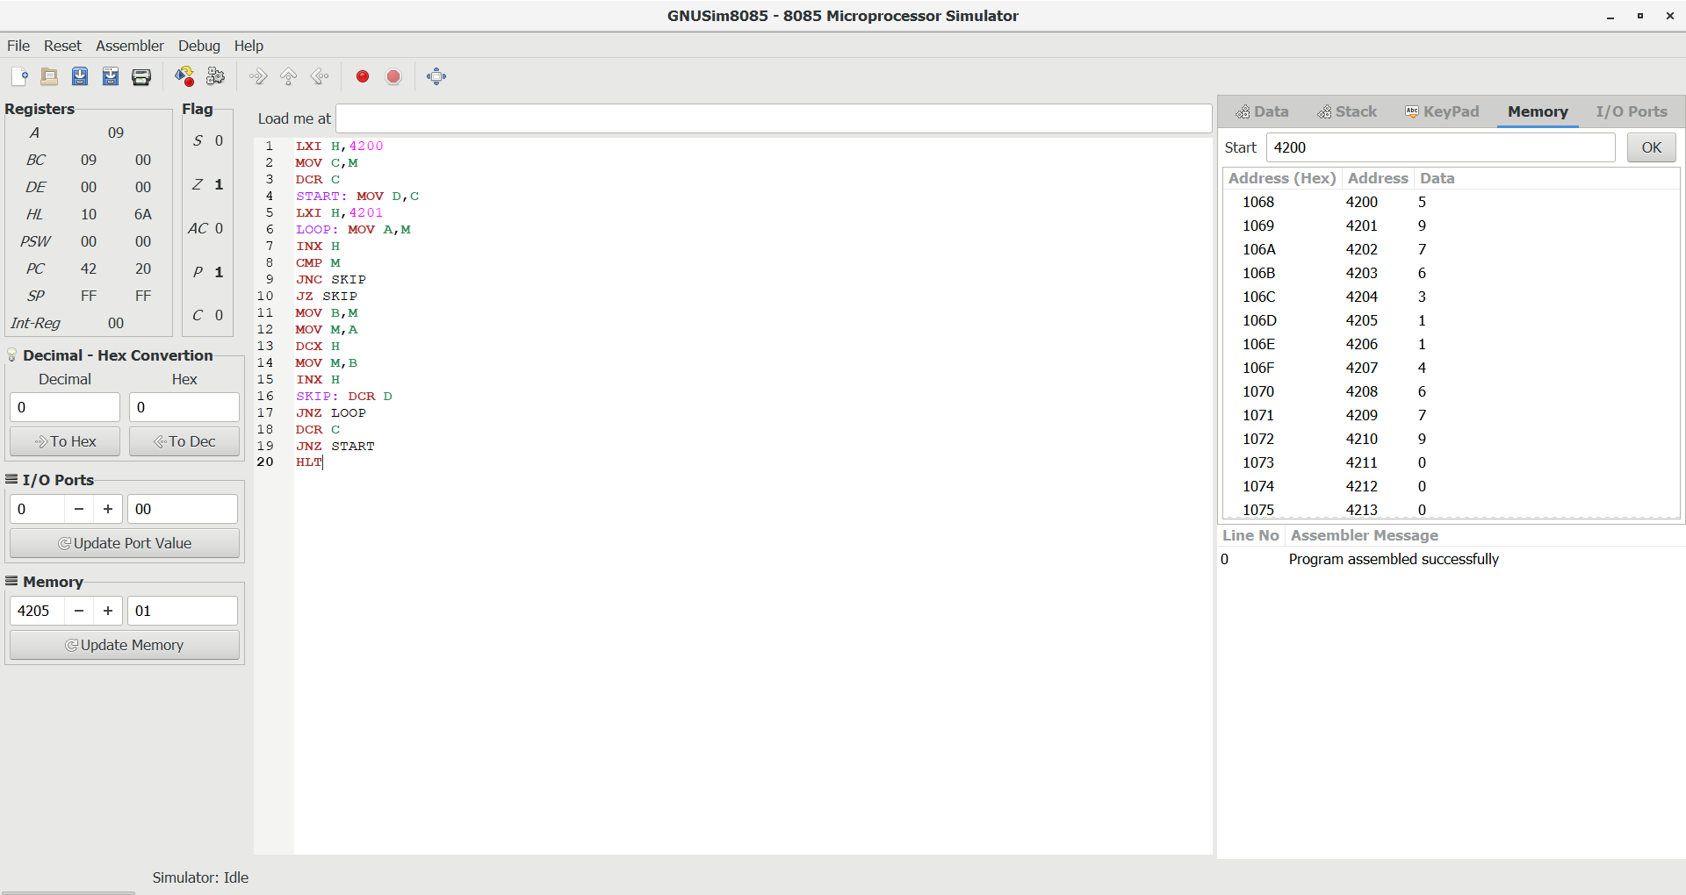

16.Write an assembly language program to find the largest number in an array.

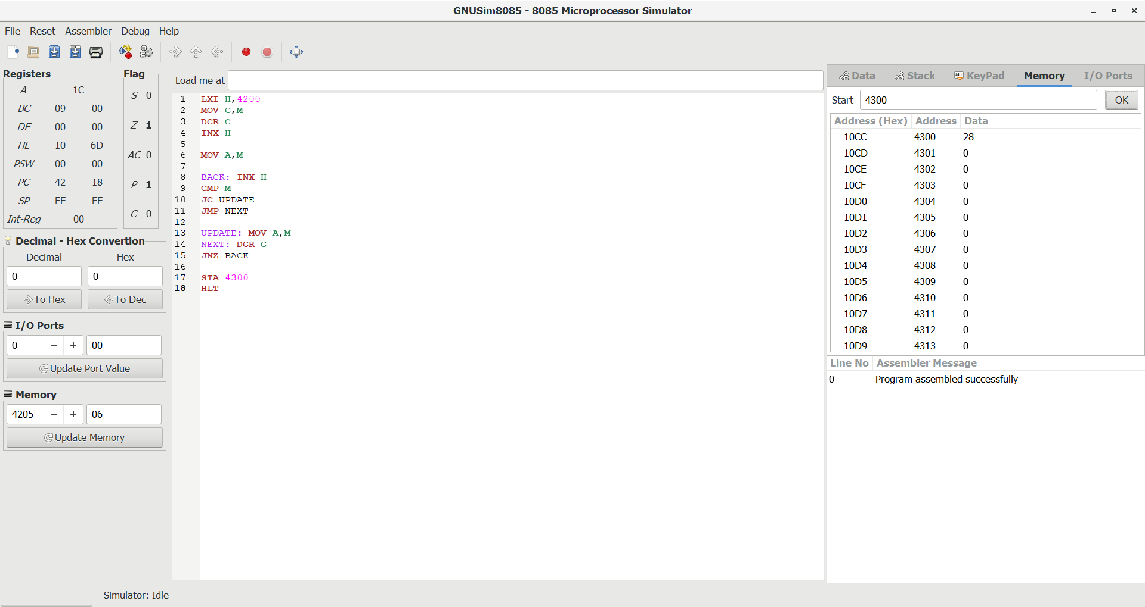

17. Write an assembly language program to find the Minimum number in an array.

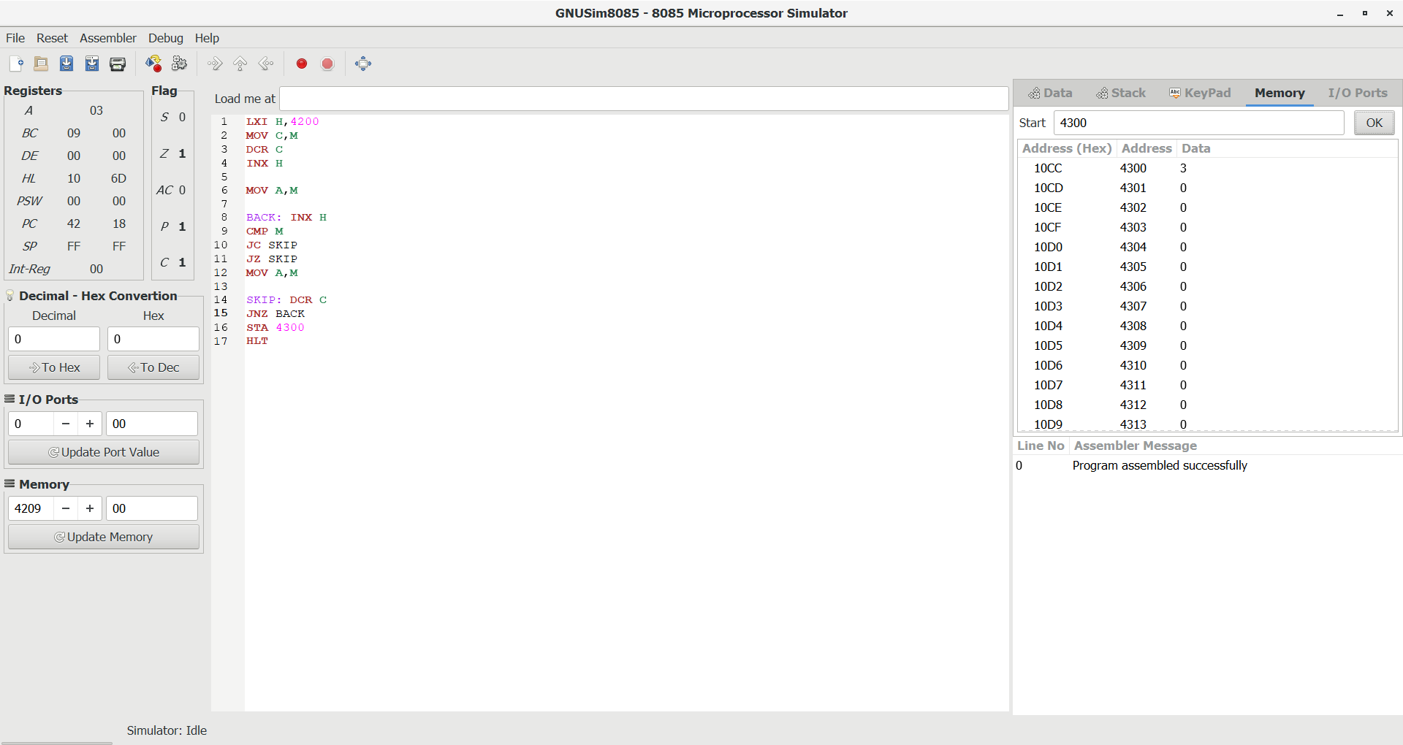

18.LCM of Two 8-bit Numbers using 8085
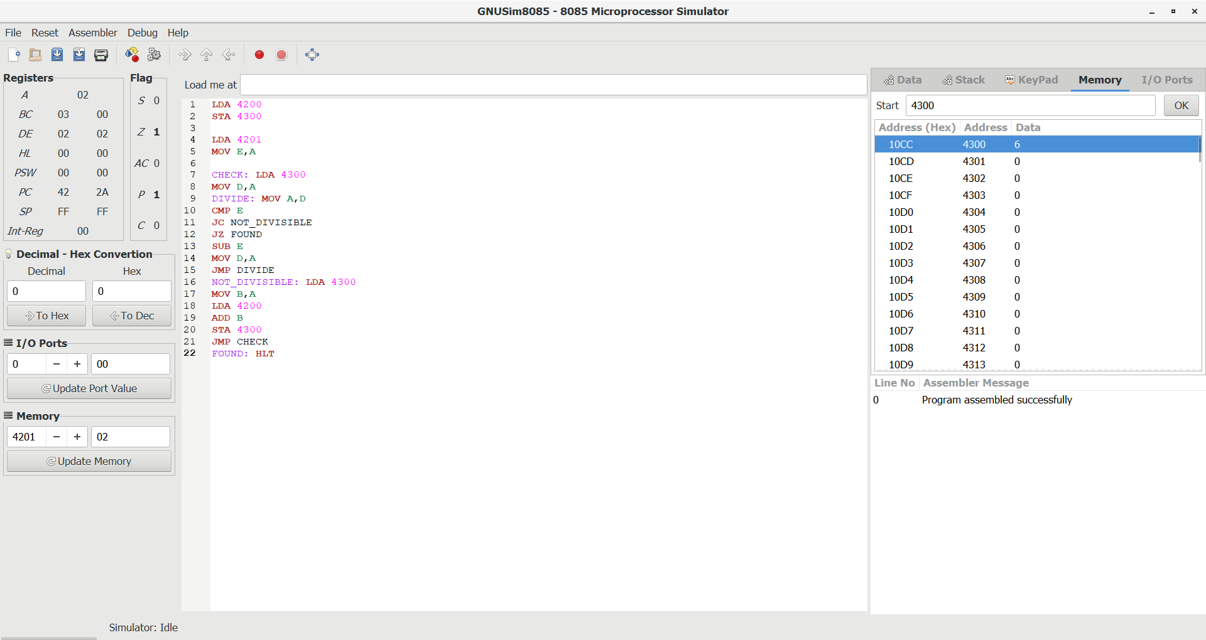

19.GCD of Two 8-bit Numbers using 8085
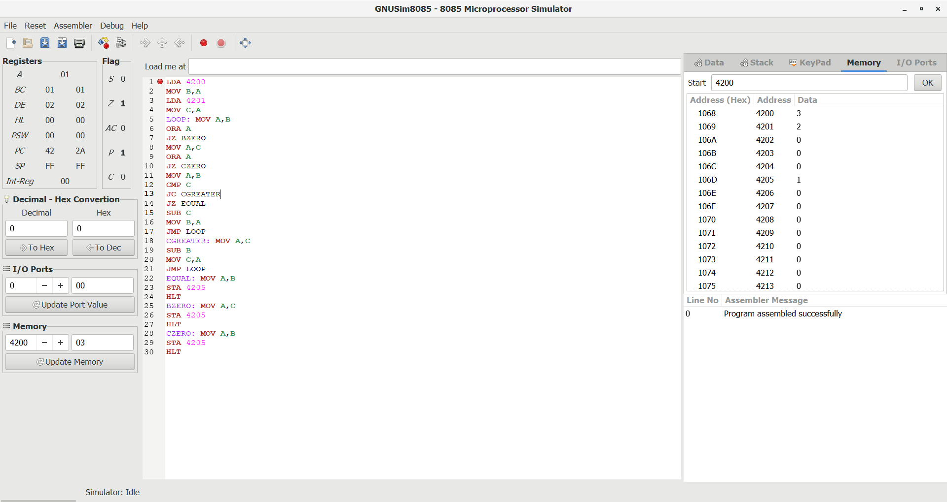

20.Factorial of an 8-bit Number using 8085
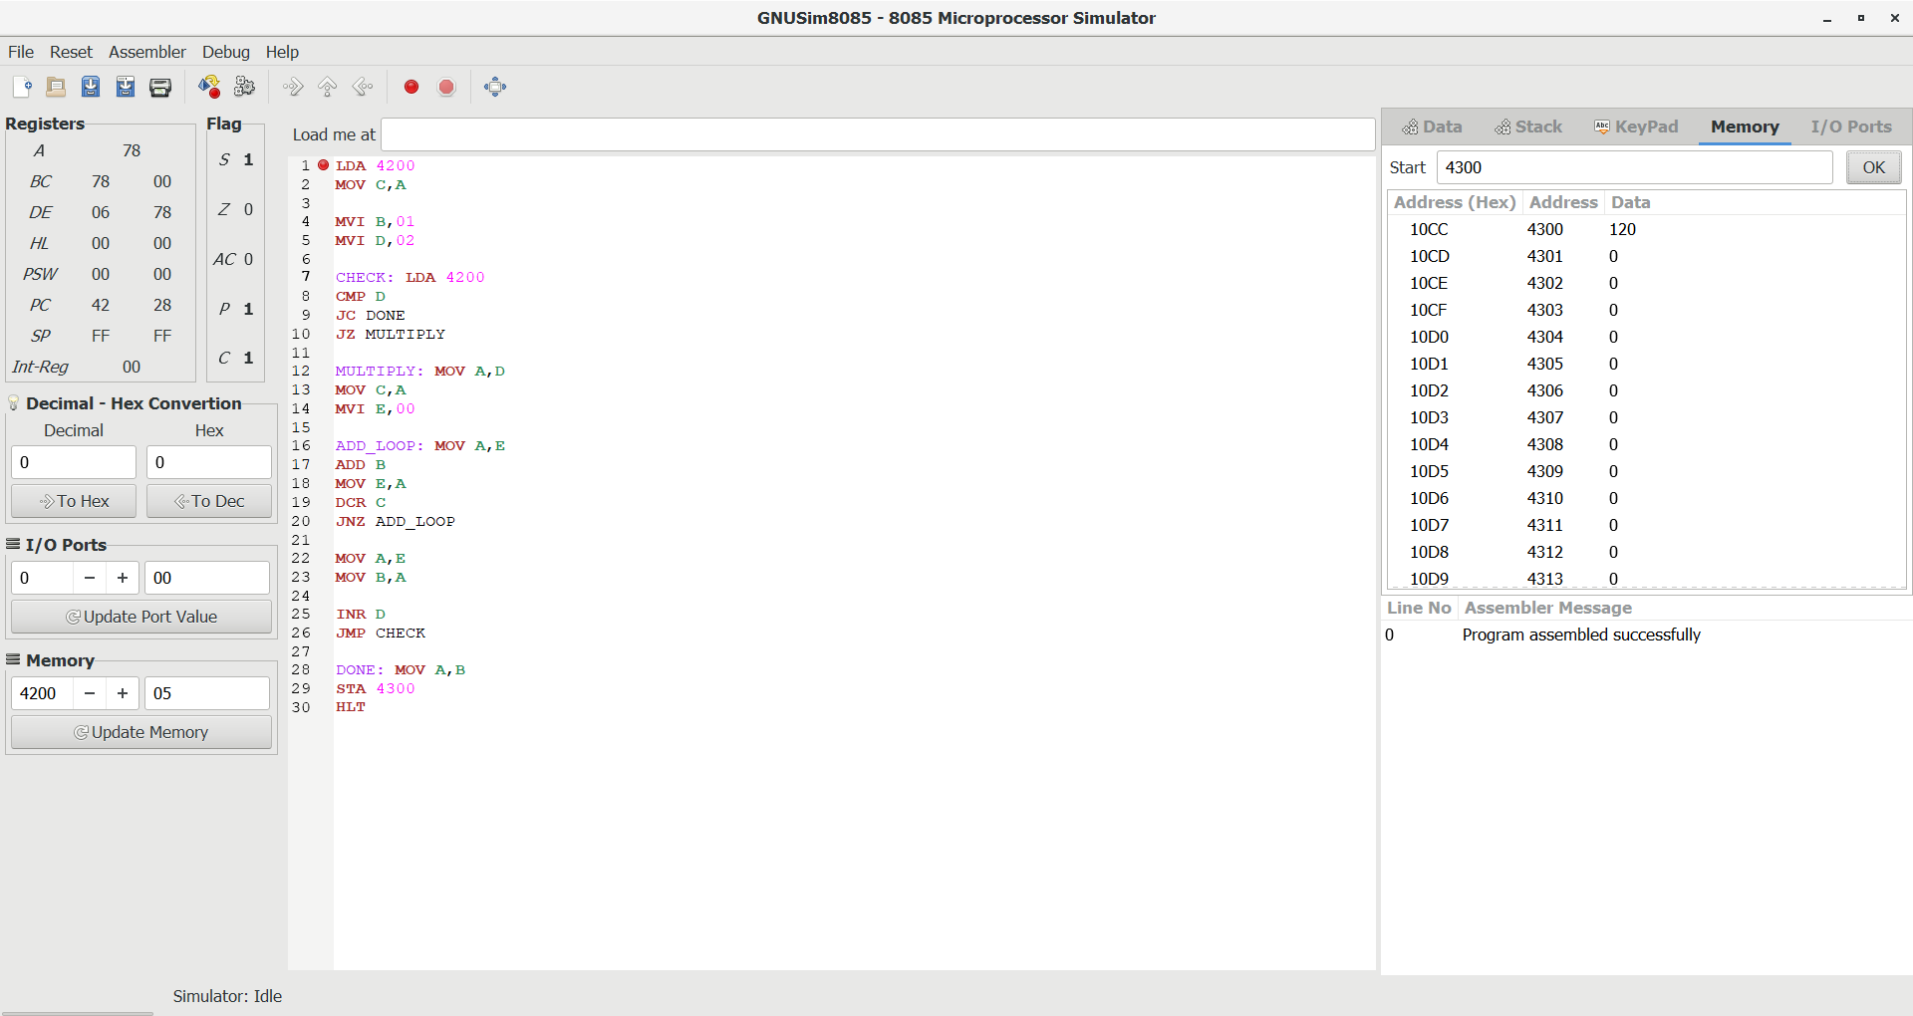

21.Convert decimal into hexadecimal
